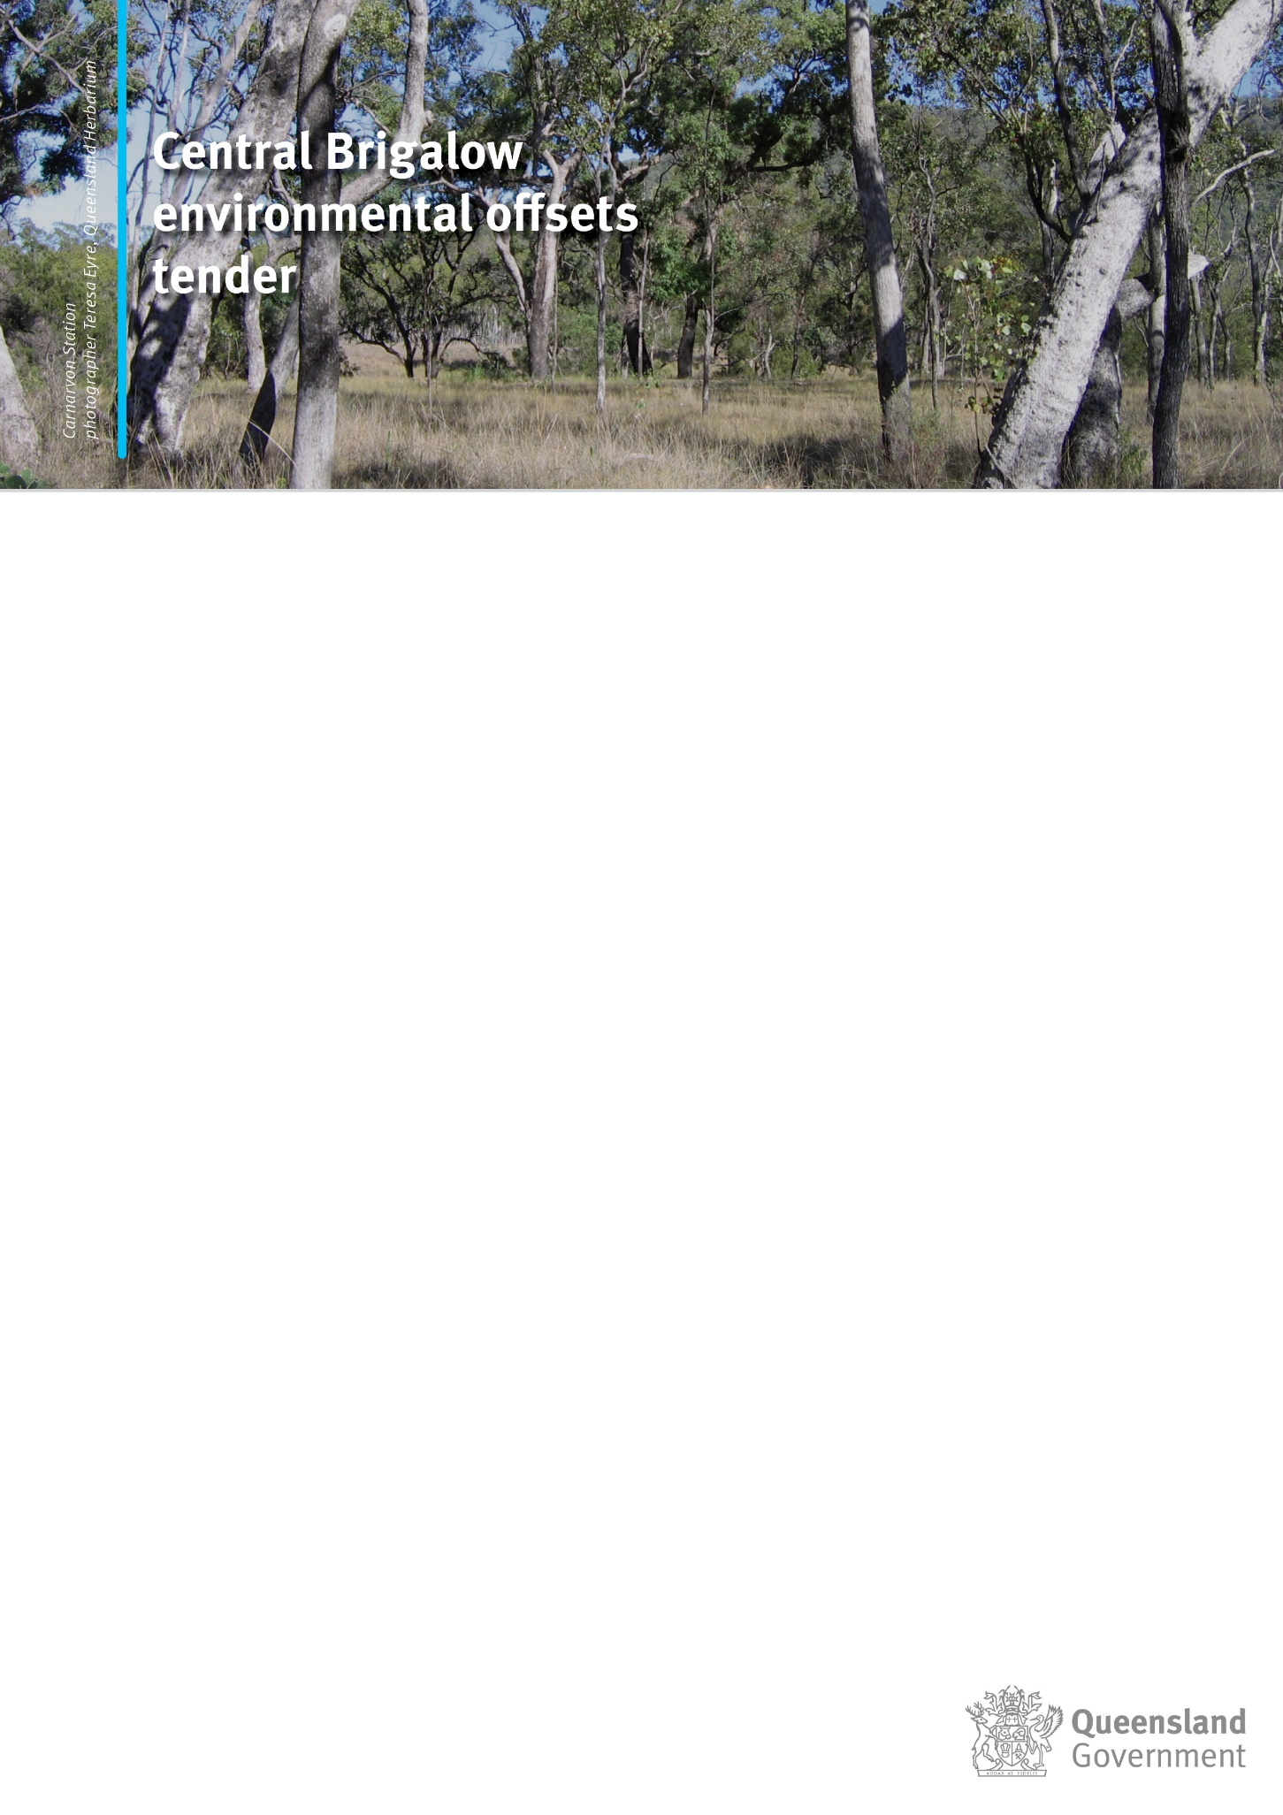
- Phase II

Expression of Interest Form

Section 1: Administrative Details

Part A – Applicant Details
Applicant Name
Organisation/Company |  | Position
ABN/ACN
Address
Postal Address |  |  |  | same as previous | ☐
Telephone |  | Mobile
Email
Preferred contact method
How did you hear about the offsets tender:
Relationship (if not landholder) Solicitor ☐ Family Member/Friend ☐ Other ☐

Part B – Landholder Details……………………………………..…………………….….Same As Previous ☐

1 | Name |  | 4 | Name
2 | Name |  | 5 | Name
3 | Name |  | 6 | Name

Part C – Property Details
Property Name |  | Size (ha)
Address
Primary land use
LGA/S

Part D – Lot on Plan and Tenure Details
Lot |  | Plan |  | Tenure
Lot |  | Plan |  | Tenure
Lot |  | Plan |  | Tenure

Section 2: Offset Values

Please provide details in the table below of the types of offset values present on your land.
A map of your property showing the offset values present on your land based on current mapping, can also be accessed by clicking on the following link and entering your lot on plan details. Map of Offset Values on Your Land.

(Please also include details or photographs of any unmapped values and/or where values may differ from those indicated on current vegetation maps. Note, you may add the same value more than once for remnant/regrowth, as well as for different VM Categories and or different areas of your property. All information will also be kept confidential.)
Note: To lookup regional ecosystem descriptions, please refer to the Queensland Herbarium’s Regional Ecosystem Descriptive Database and enter the applicable regional ecosystem number in the box provided here. (hold Ctrl button and click link)

Location | Approximate Mapping Coordinates or Location Description | Offset Values | Approximate Area (ha) | Regional Ecosystems (if known, see table 1) | Same as Mapped RE/s  (Yes/No) | If “No” provide further details where needed below | Remnant/Regrowth | VM Category | Labelled Photos Attached
1 | Enter Coordinates or Description | Choose an item. | Hectares | Enter RE Number | Choose Item | Provide Details Here | Choose an item. | Choose an item. | ☐
2 | Enter Coordinates or Description | Choose an item. | Hectares | Enter RE Number | Choose Item | Provide Details Here | Choose an item. | Choose an item. | ☐
3 | Enter Coordinates or Description | Choose an item. | Hectares | Enter RE Number | Choose Item | Provide Details Here | Choose an item. | Choose an item. | ☐
4 | Enter Coordinates or Description | Choose an item. | Hectares | Enter RE Number | Choose Item | Provide Details Here | Choose an item. | Choose an item. | ☐
5 | Enter Coordinates or Description | Choose an item. | Hectares | Enter RE Number | Choose Item | Provide Details Here | Choose an item. | Choose an item. | ☐
6 | Enter Coordinates or Description | Choose an item. | Hectares | Enter RE Number | Choose Item | Provide Details Here | Choose an item. | Choose an item. | ☐
7 | Enter Coordinates or Description | Choose an item. | Hectares | Enter RE Number | Choose Item | Provide Details Here | Choose an item. | Choose an item. | ☐
8 | Enter Coordinates or Description | Choose an item. | Hectares | Enter RE Number | Choose Item | Provide Details Here | Choose an item. | Choose an item. | ☐
9 | Enter Coordinates or Description | Choose an item. | Hectares | Enter RE Number | Choose Item | Provide Details Here | Choose an item. | Choose an item. | ☐
10 | Enter Coordinates or Description | Choose an item. | Hectares | Enter RE Number | Choose Item | Provide Details Here | Choose an item. | Choose an item. | ☐
11 | Enter Coordinates or Description | Choose an item. | Hectares | Enter RE Number | Choose Item | Provide Details Here | Choose an item. | Choose an item. | ☐
12 | Enter Coordinates or Description | Choose an item. | Hectares | Enter RE Number | Choose Item | Provide Details Here | Choose an item. | Choose an item. | ☐
13 | Enter Coordinates or Description | Choose an item. | Hectares | Enter RE Number | Choose Item | Provide Details Here | Choose an item. | Choose an item. | ☐
14 | Enter Coordinates or Description | Choose an item. | Hectares | Enter RE Number | Choose Item | Provide Details Here | Choose an item. | Choose an item. | ☐
15 | Enter Coordinates or Description | Choose an item. | Hectares | Enter RE Number | Choose Item | Provide Details Here | Choose an item. | Choose an item. | ☐
16 | Enter Coordinates or Description | Choose an item. | Hectares | Enter RE Number | Choose Item | Provide Details Here | Choose an item. | Choose an item. | ☐
17 | Enter Coordinates or Description | Choose an item. | Hectares | Enter RE Number | Choose Item | Provide Details Here | Choose an item. | Choose an item. | ☐
18 | Enter Coordinates or Description | Choose an item. | Hectares | Enter RE Number | Choose Item | Provide Details Here | Choose an item. | Choose an item. | ☐
19 | Enter Coordinates or Description | Choose an item. | Hectares | Enter RE Number | Choose Item | Provide Details Here | Choose an item. | Choose an item. | ☐
20 | Enter Coordinates or Description | Choose an item. | Hectares | Enter RE Number | Choose Item | Provide Details Here | Choose an item. | Choose an item. | ☐

Table 1 - List of Offset Target Values and Associated Brigalow Regional Ecosystems
Offset Values | Associated Regional Ecosystems
Poplar_box_woodlands (Endangered and Of Concern REs) | 11.12.17;11.3.2; 11.4.12; 11.4.2; 11.5.13; 11.8.15; 11.9.7
Watercourse_vegetation | Any Brigalow regional ecosystem, fringing a mapped watercourse
Squatter_pigeon_habitat | Any Brigalow regional ecosystem, that’s also mapped squatter pigeon habitat or where you have evidence or know of squatter pigeons occurring.

Section 3: Other Information

Please provide details of any other information about your property that you consider to be relevant to this project

(Photographs are encouraged to help provide additional information. Other information, such as weeds and feral animals, as well as information on current management practices to address any threats and any relevant infrastructure that may be beneficial to managing an offset site over time).

Click or tap here to enter text.

Section 4: Lodging Details
Please send your completed application to the Fitzroy Basin Association by COB 11 October 2021, via:
- Email: admin@fba.org.au
- Post (marked CBFOT Phase 2 EOI): c/of PO Box 139, Rockhampton QLD 4700; or
- In person at one of FBA’s Offices located in Emerald, Gladstone, Rockhampton or Theodore.

Note: All information provided will be kept confidential and will be used for the purpose of this project only.

